**Practical 9**

**Aim: Install, configure and run Apache Strom**

**Install ZooKeeper**

sudo apt install -y zookeeperd

**Start the ZooKeeper service:**

**sudo systemctl start zookeeper**

**sudo systemctl enable zookeeper**

**sudo systemctl status zookeeper**

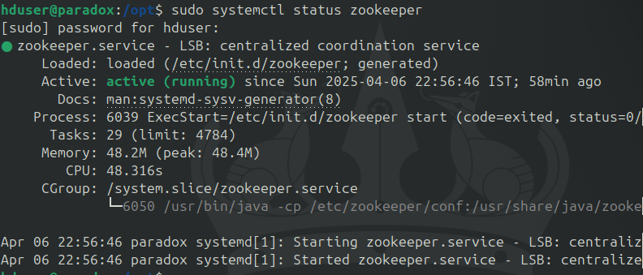

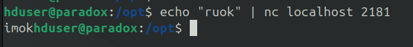

**Download and Install Apache Storm in /opt**

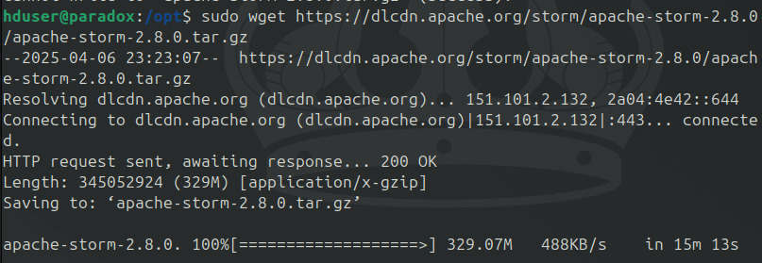sudo wget <https://dlcdn.apache.org/storm/apache-storm-2.8.0/apache-storm-2.8.0.tar.gz>

**Sudo**

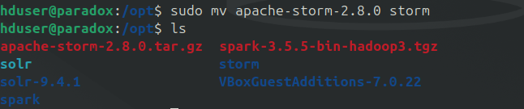**Extract the archive and rename it to Storm:**

**Configure Apache Storm**

Add this lines in nano /opt/storm/conf/storm.yaml

storm.zookeeper.servers:

- "localhost"

nimbus.seeds: ["localhost"]

supervisor.slots.ports:

- 6700

- 6701

- 6702

- 6703

ui.port: 8080

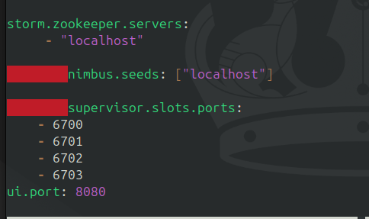

**Create the local directory:**

sudo mkdir /opt/storm/tmp

**Start Apache Storm Services**

In separate terminal tabs or with tmux/screen, run the following components:

**Nimbus (Master node):**

cd /opt/storm

sudo bin/storm nimbus

**Supervisor (Worker node):**

cd /opt/storm

sudo bin/storm supervisor

**Storm UI (Web interface):**

cd /opt/storm

sudo bin/storm ui

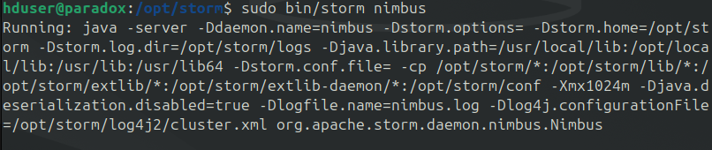

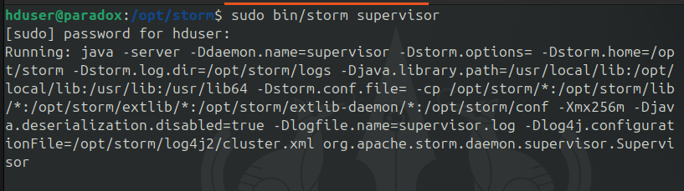

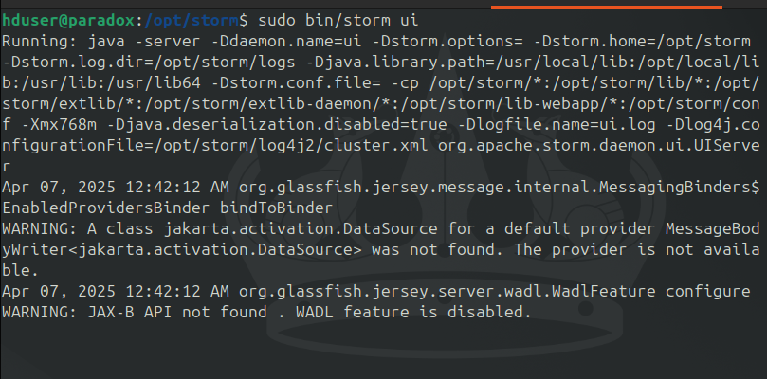

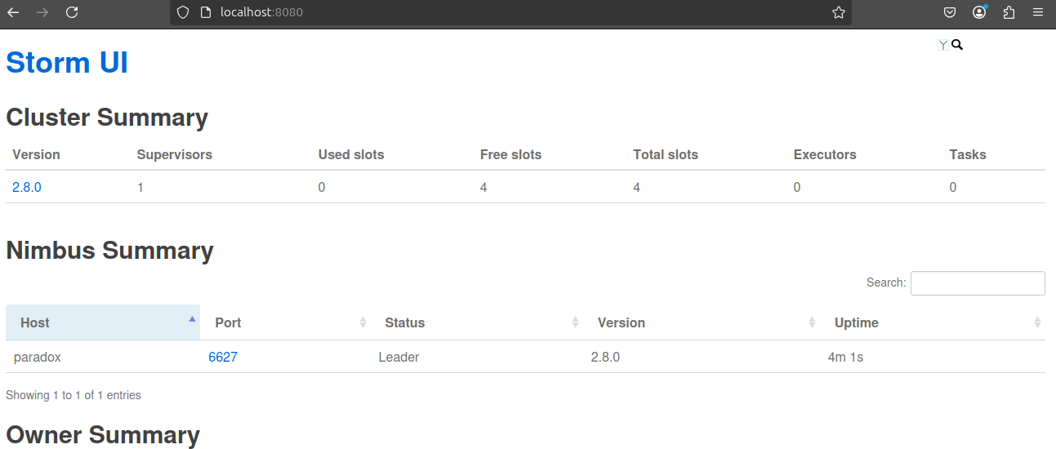

**Download the SampleTopology**

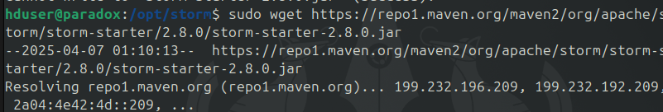sudo wget <https://repo1.maven.org/maven2/org/apache/storm/storm-starter/2.8.0/storm-starter-2.8.0.jar>

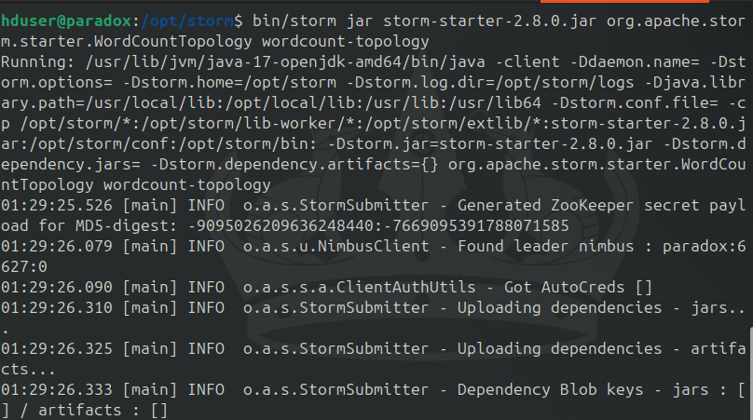**Submit the Topology**

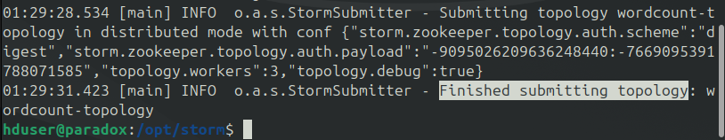

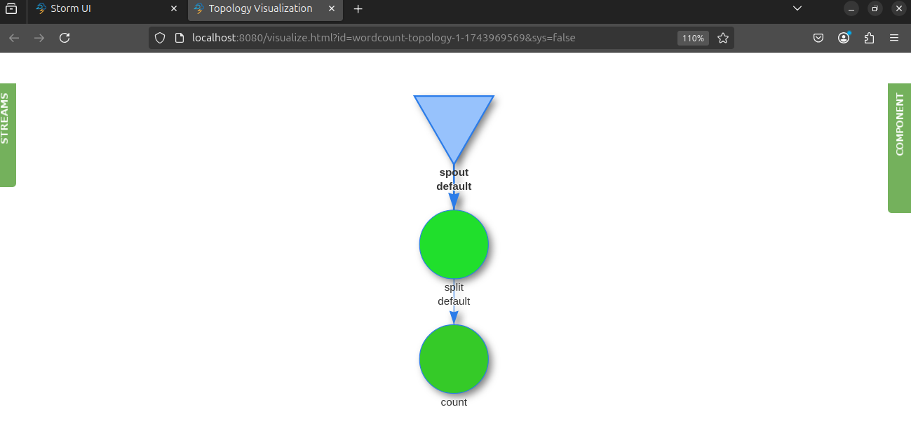  
**Topology Visualization**

**Stop the Topology**

bin/storm kill wordcount-topology

**Conclusion:** Practical to Install, configure and run Apache Strom is successfully completed.